**Front-End UI/UX Mini Project**

* **Project Title:** *Responsive Portfolio Website Detailing Our Favourite City.*
* **Submitted By**: 
  + *2462311 Aksa Mariya Basil* [aksa.mariyabasil@btech.christuniversity.in](mailto:aksa.mariyabasil@btech.christuniversity.in)
  + *2462360 Sanjana Sudhir Ullal*

[sanjana.sudhir@btech.christuniversity.in](mailto:sanjana.sudhir@btech.christuniversity.in)

* + *2462332* *Joel Anthony Dsilva*

[*joel.anthony@btech.christuniversity.in*](mailto:joel.anthony@btech.christuniversity.in)

* **Course**:  *UI/UX Design Fundamentals*
* **Instructor Name**: Ms. Nagaveena
* **Institution**:  *Christ University*
* **Date of Submission**: *13/08/2025*
* **Published Output**: [*https://joel-dsilva.github.io/My-Favourite-City/navigation.html*](https://joel-dsilva.github.io/My-Favourite-City/navigation.html)

**2. Abstract**

This project presents an interactive web-based exploration of **Udaipur**, often referred to as the "City of Lakes." Built using HTML and CSS, the website offers users an immersive experience into the city's rich heritage, architectural marvels, and vibrant culture. The navigation page serves as the central hub, guiding visitors through various sections:

* **Home**: An introduction to Udaipur's historical significance and scenic beauty.
* **Attractions**: Detailed insights into iconic landmarks such as the City Palace, Lake Pichola, and Jag Mandir.
* **Culture**: An overview of Udaipur's traditional arts, festivals, and local crafts.
* **Gallery**: A curated collection of images showcasing the city's landscapes and architectural wonders.
* **Contact**: Information for visitors seeking further details or planning a trip.

Through this project, users can virtually traverse Udaipur, gaining an appreciation for its timeless charm and cultural richness.

**3. Objectives**

* Design a user-friendly interface using modern UI principles
* Develop a fully responsive layout using only HTML and CSS
* Implement structured HTML5 semantic elements
* Apply CSS styling for branding, layout, and responsive behavior
* Ensure accessibility and readability across devices

**4. Scope of the Project**

* Focused on front-end design only
* No JavaScript or server-side integration
* Intended for desktop, tablet, and mobile viewports
* Used only open-source tools and pure code (no libraries)

**5. Tools & Technologies Used**

| Tool/Technology | Purpose |
| --- | --- |
| HTML5 | Markup and content structure |
| CSS3 | Styling and layout management |
| VS Code | Code editor |
| Chrome DevTools | Testing and debugging |

**6. HTML Structure Overview**

* Used semantic tags: <header>, <nav>, <main>, <section>, <footer>
* Structured into reusable sections: About, Projects, Contact
* Navigation menu using <ul> and anchor links for smooth scrolling

**7. CSS Styling Strategy**

* Used external CSS file (style.css)
* Organized with comments and sections
* Techniques used:
  + Flexbox and Grid for layout
  + Media Queries for responsiveness
  + CSS Variables for theme customization
  + Hover effects and transitions
  + Mobile-first design approach

**8. Key Features**

| Feature | Description |
| --- | --- |
| Responsive Design | Adapts seamlessly to all screen sizes |
| Smooth Navigation | Fixed top nav with anchor links |
| Project Cards | Flex-based layout with hover effects |
| Contact Form (non-functional) | Placeholder layout for inputs and button |
| Accessible Fonts & Colors | High contrast and readable typography |

**9. Challenges Faced & Solutions**

| Challenge | Solution |
| --- | --- |
| Overlapping elements on small screens | Used media queries to stack elements |
| Difficulty aligning items using float | Shifted to Flexbox and Grid |
| Typography scaling issue | Used relative units (em/rem) instead of px |

**10. Outcome**

* Achieved a clean, consistent, and visually engaging front-end layout
* All key components function as intended using just HTML and CSS
* Learned about layout responsiveness and UI hierarchy in depth

**11. Future Enhancements**

* Add JavaScript for interactivity (form validation, dynamic content)
* Integrate animations or transitions
* Backend integration for form submission
* Theme toggler (light/dark mode)

**12. Sample Code**

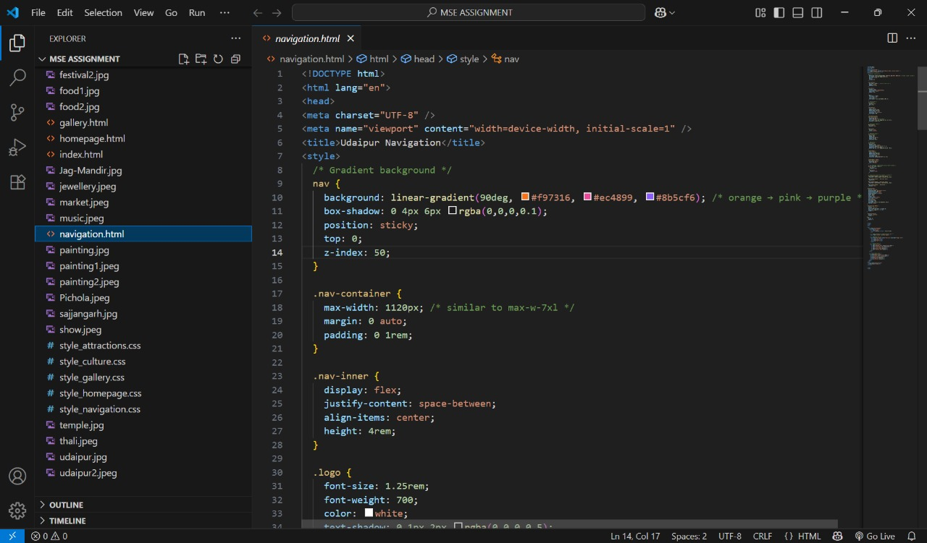

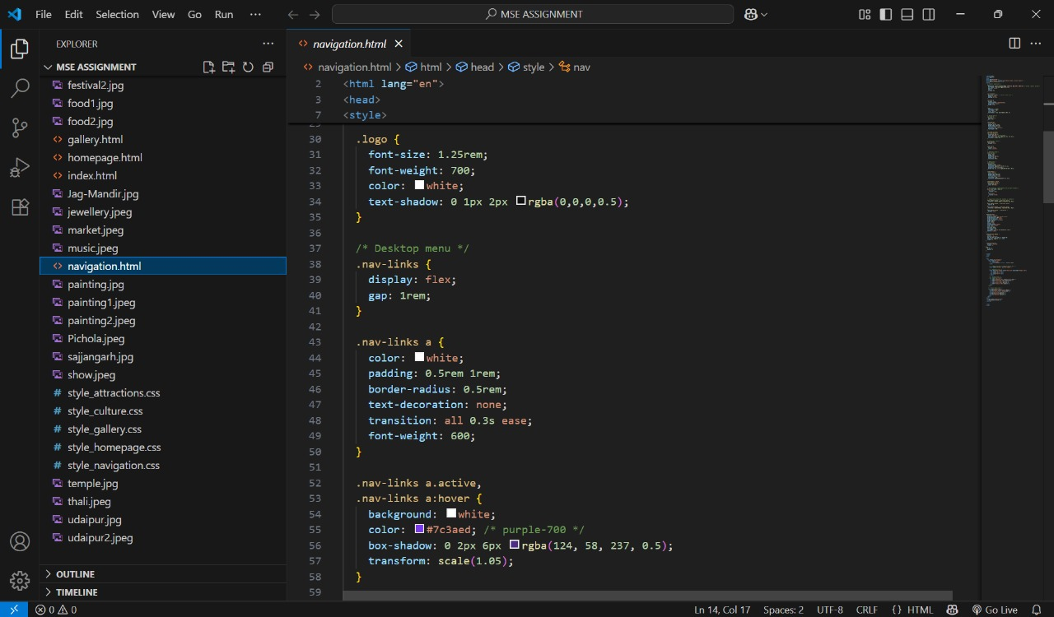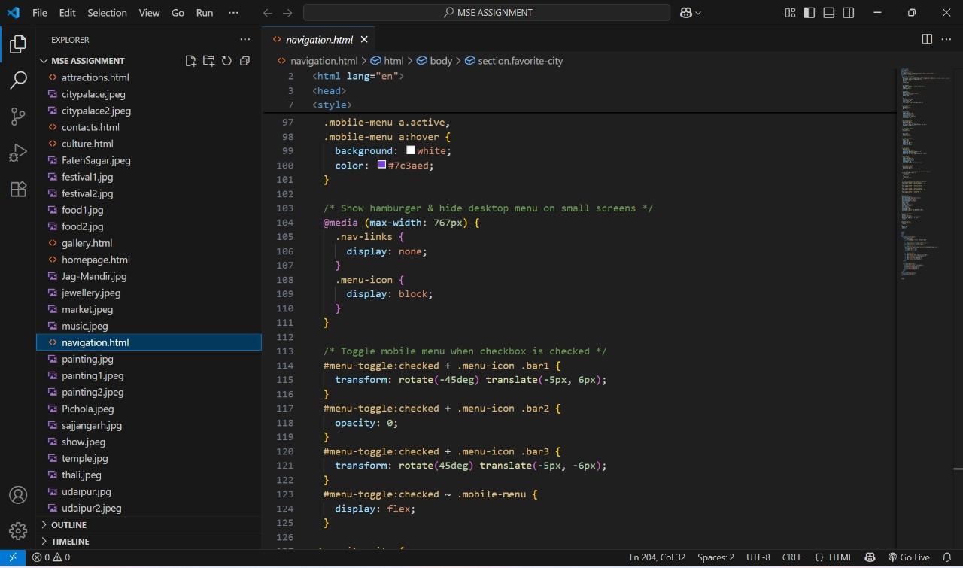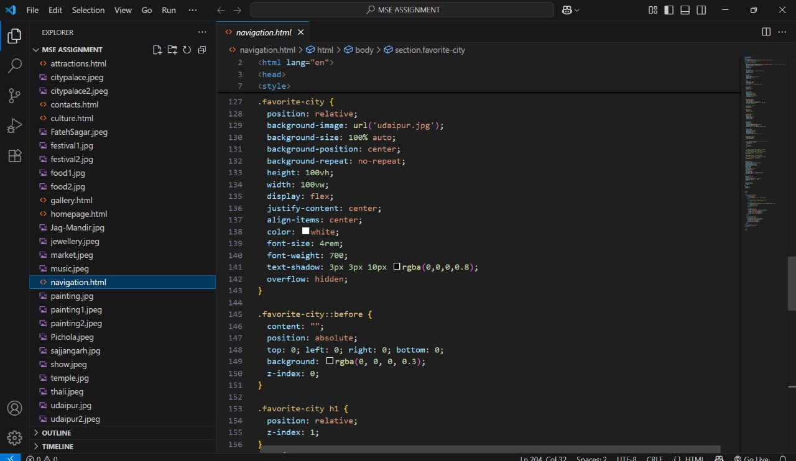

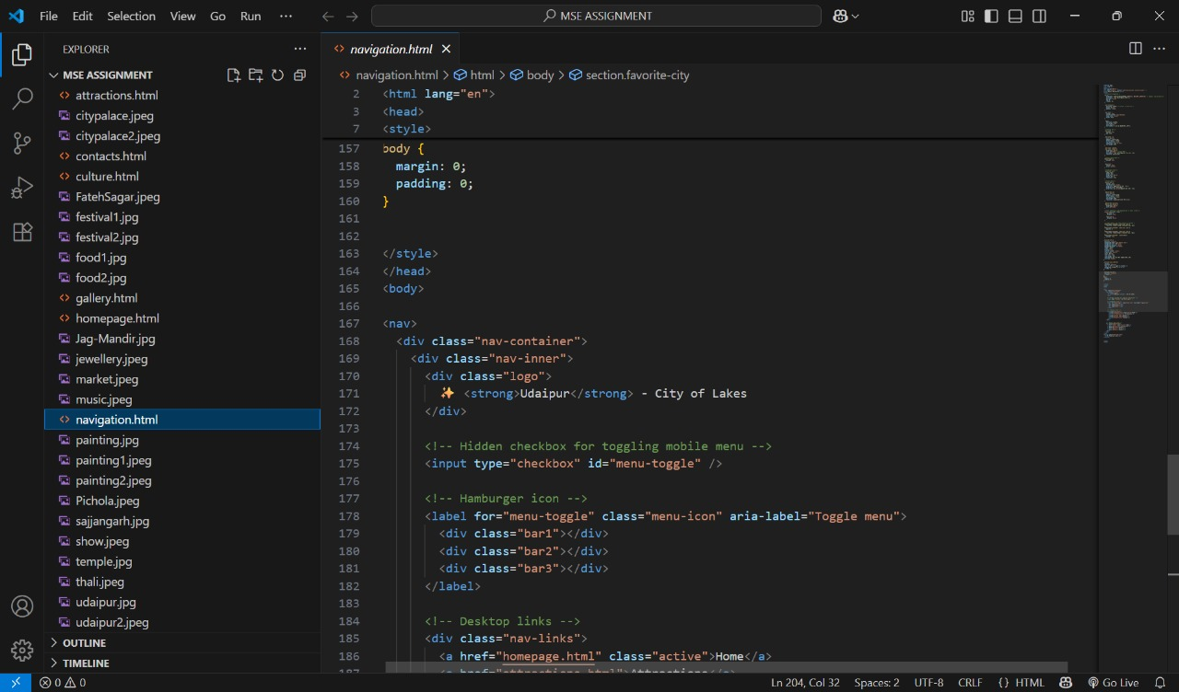

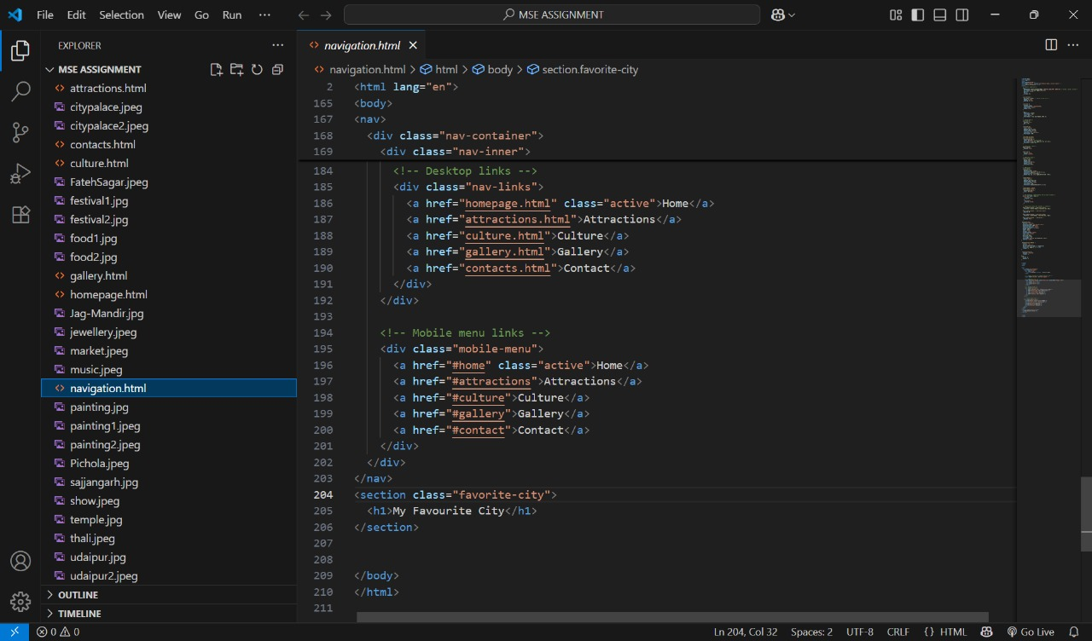

**13. Screenshots of Final Output**

Home:

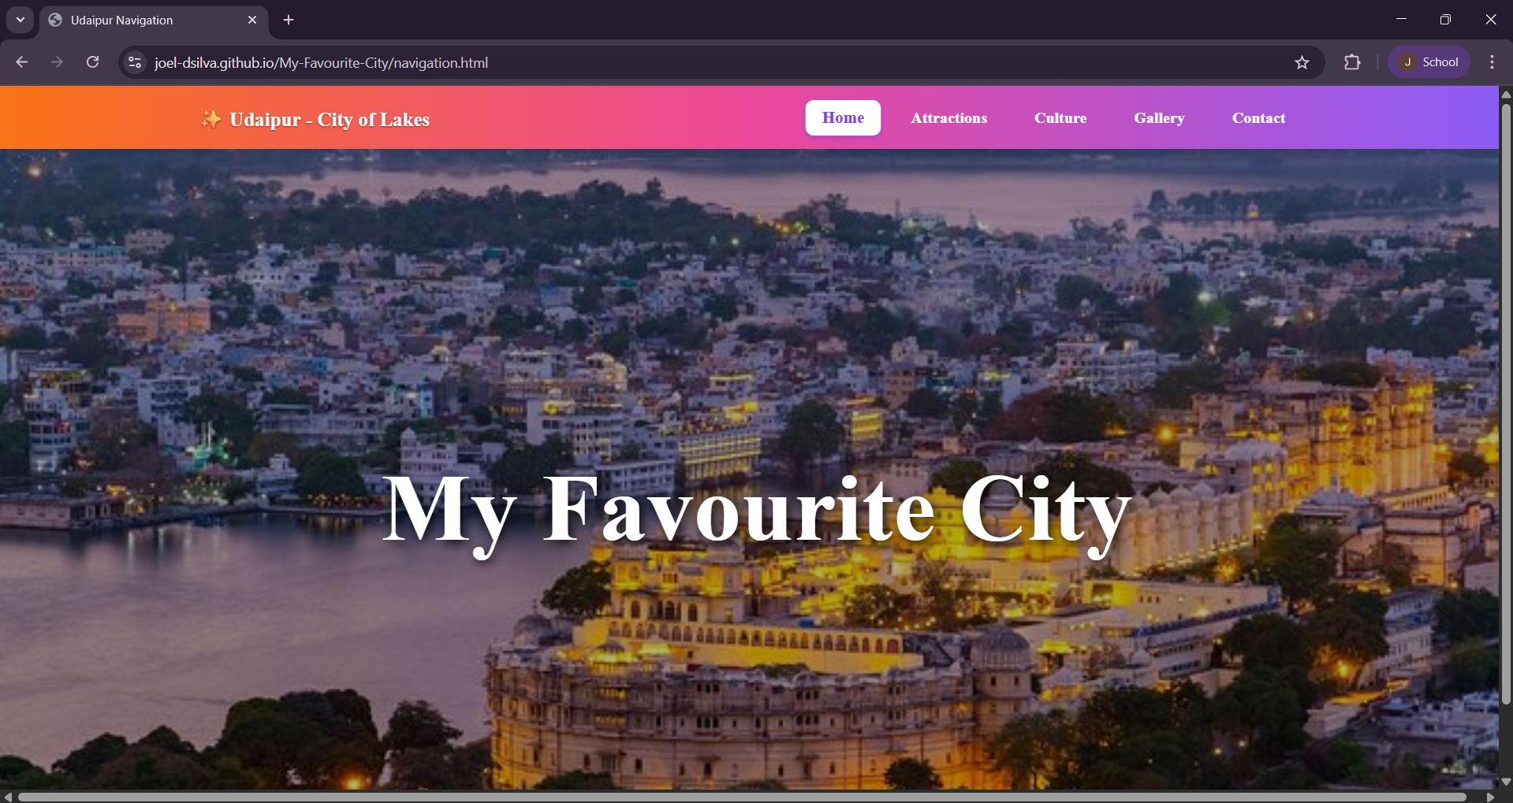

Attractions:

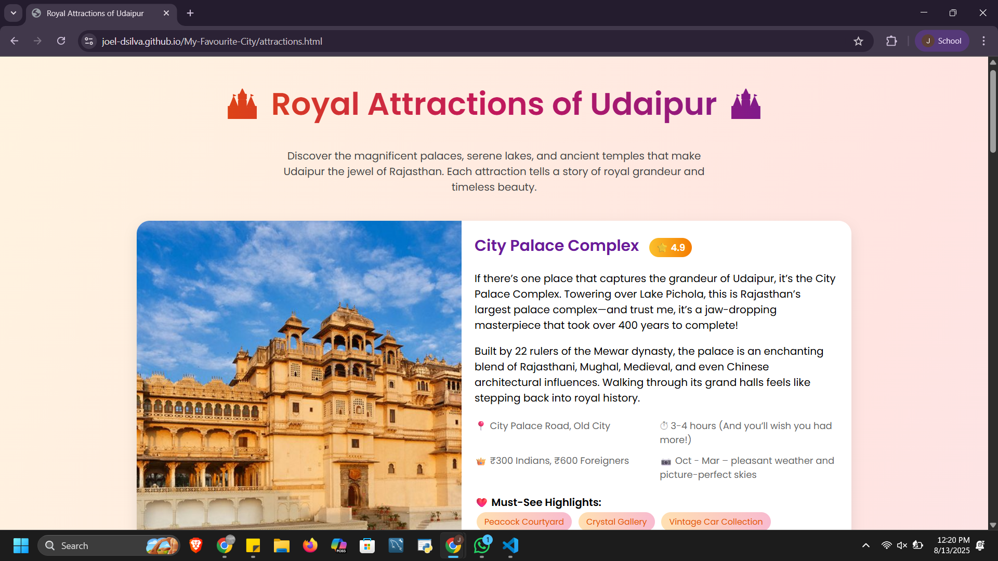

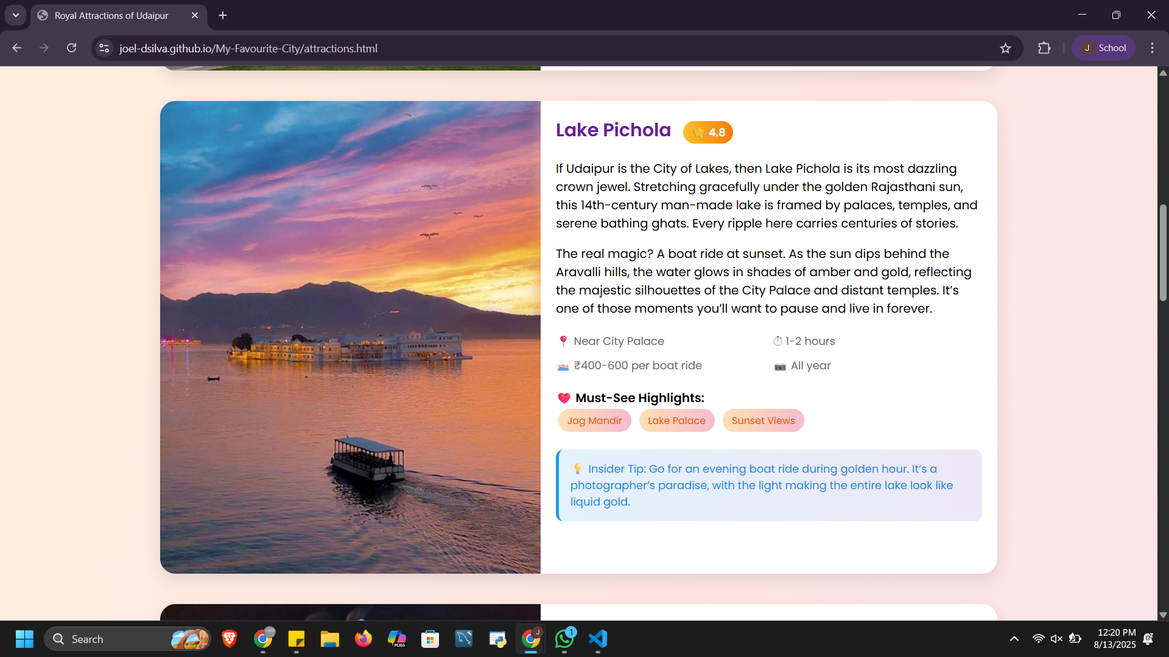

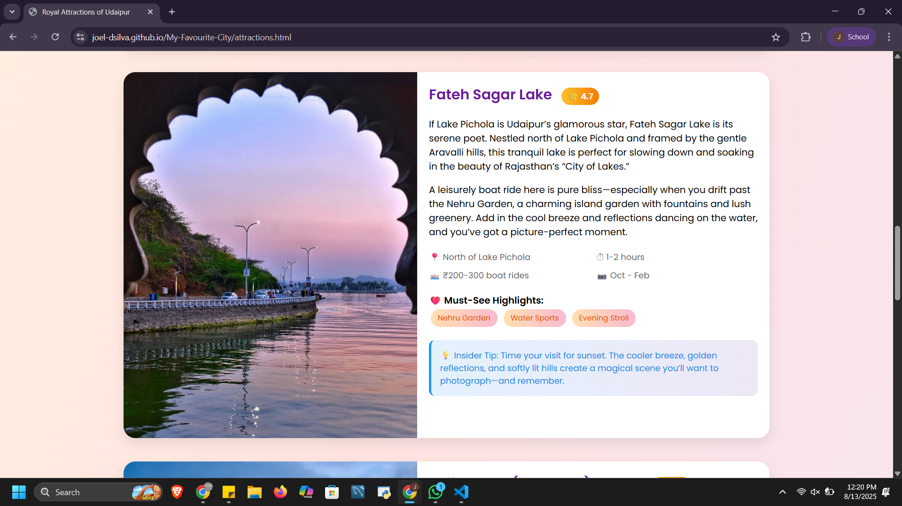

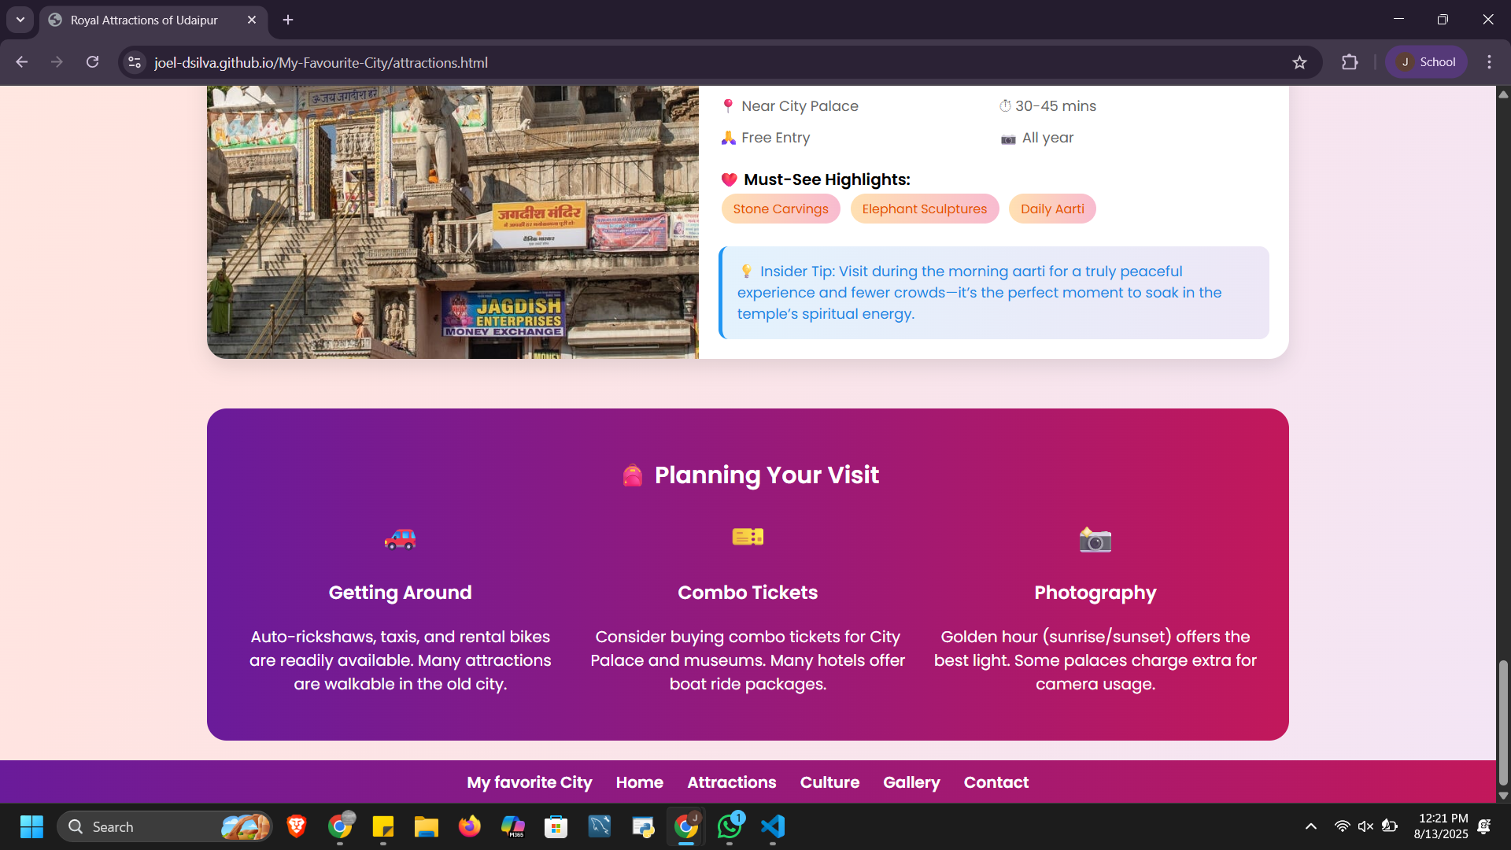

Culture:

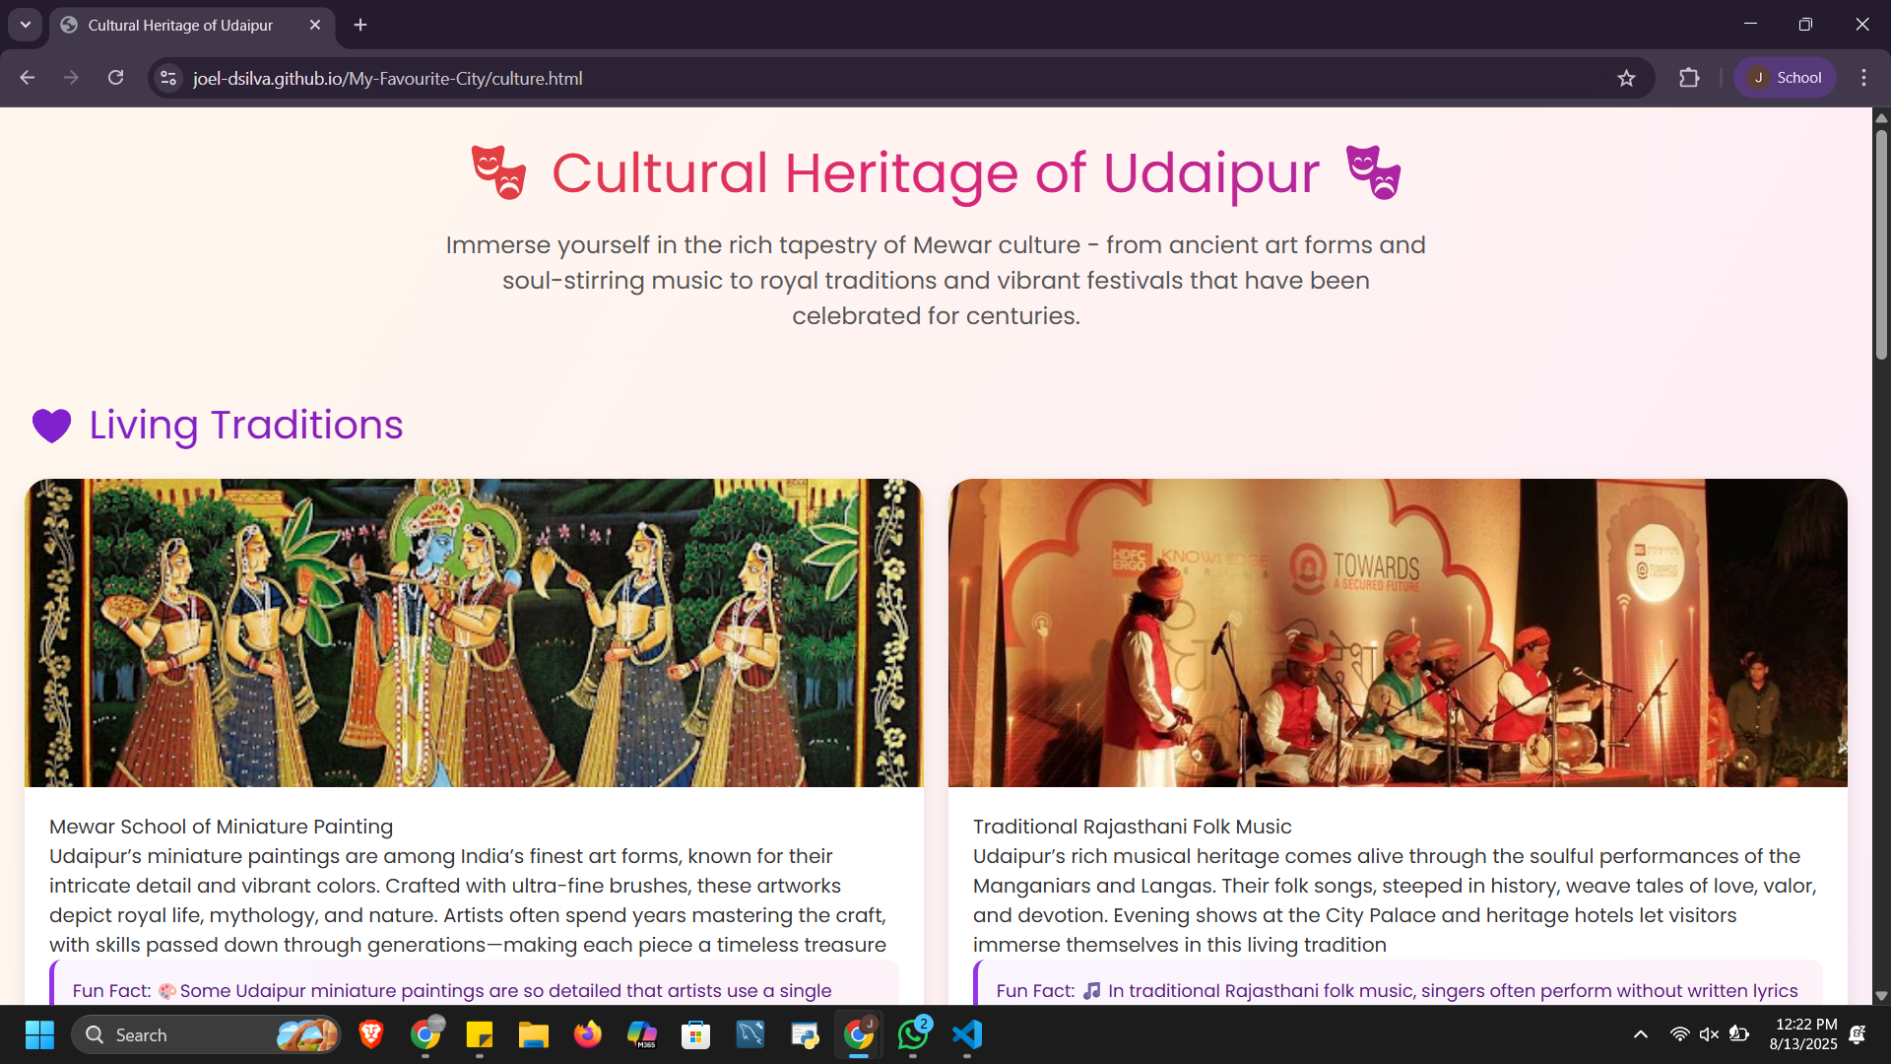

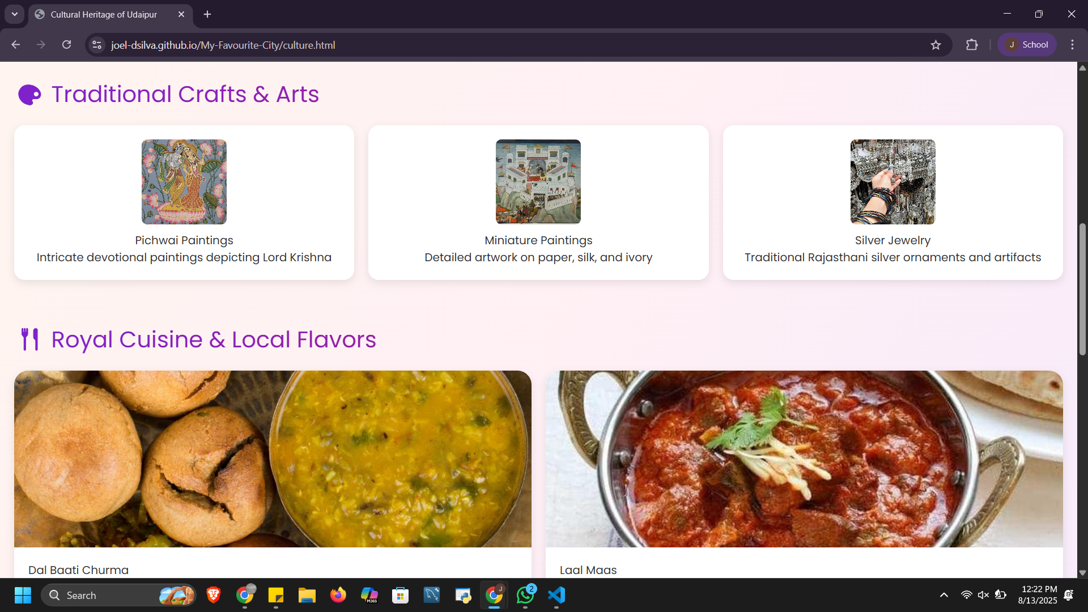

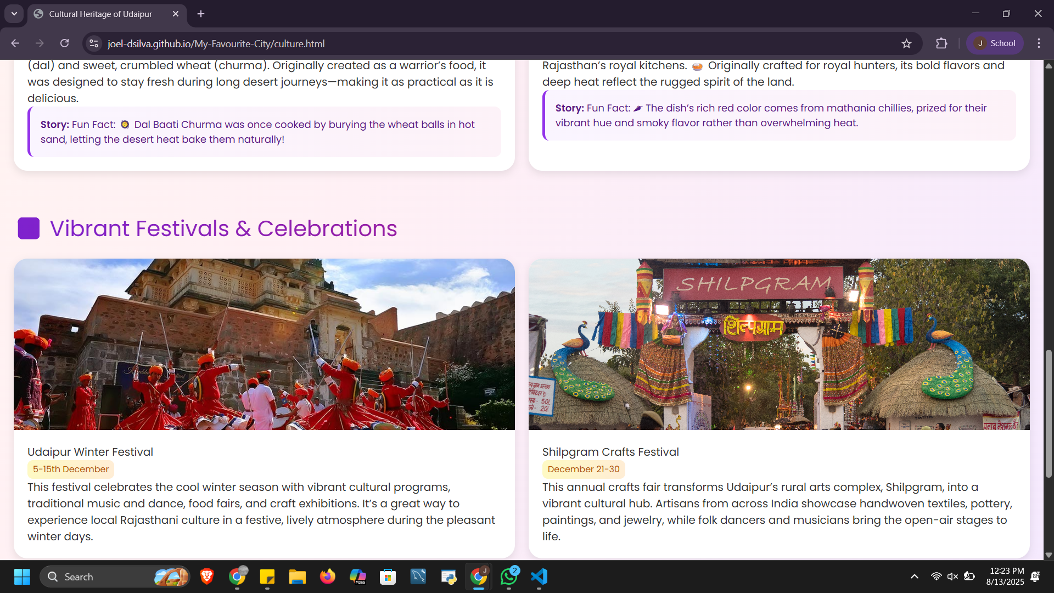

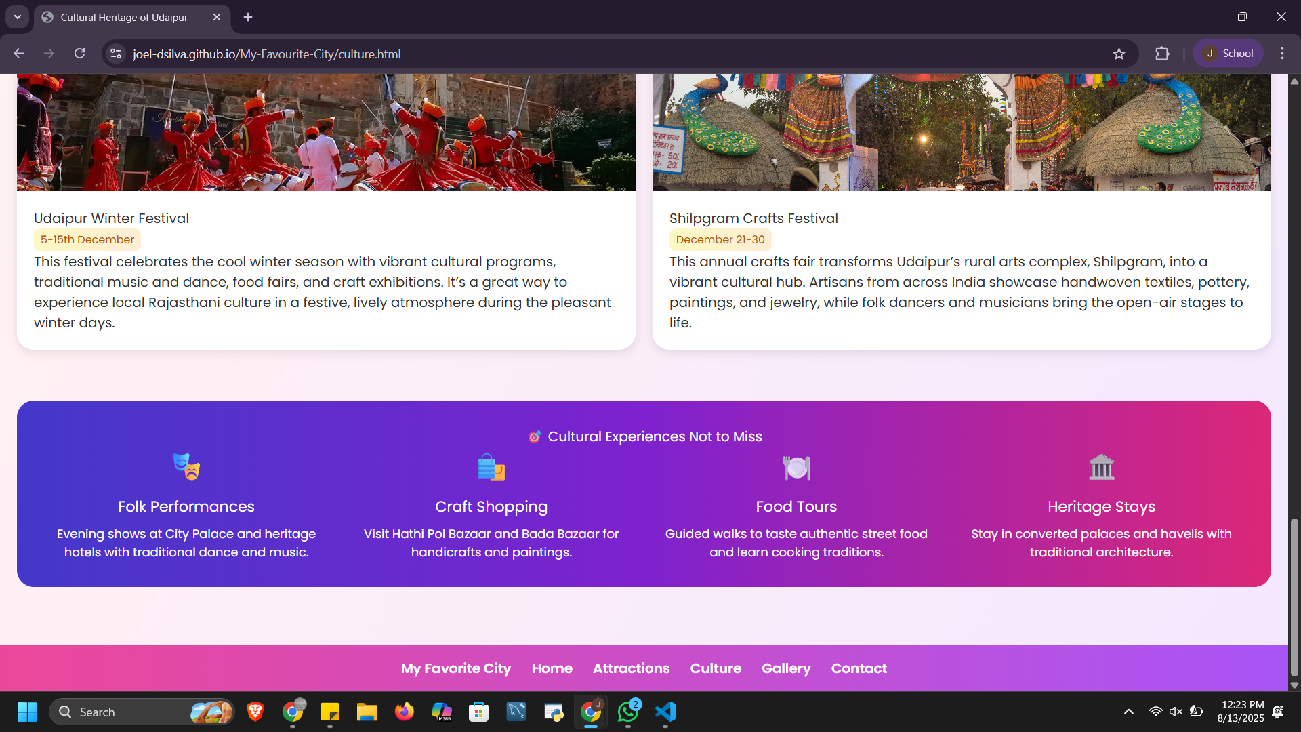

Gallery:

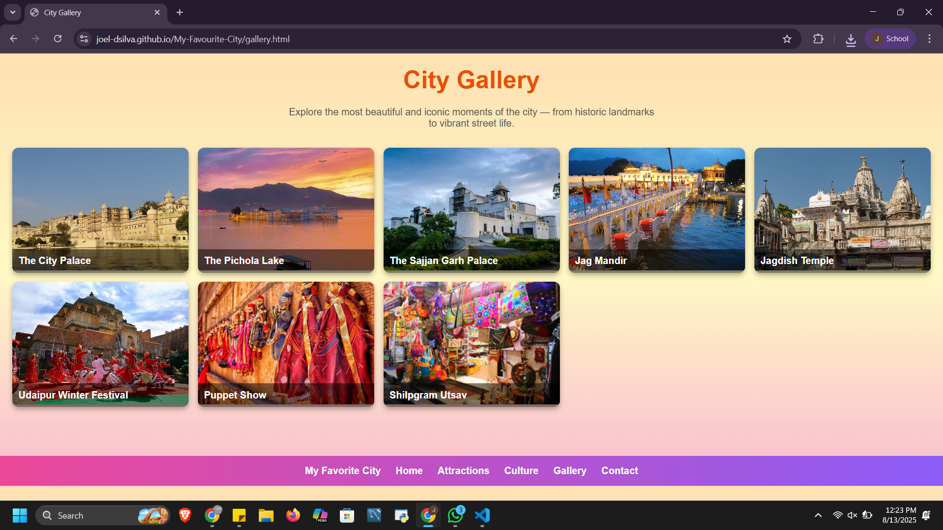

Contact:

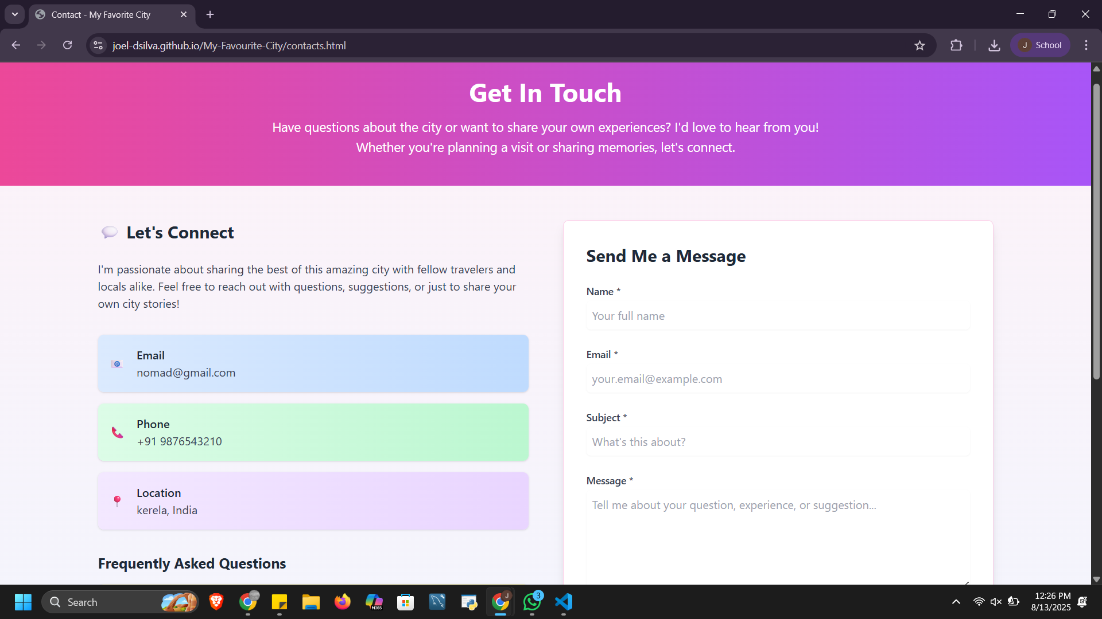

**11. Conclusion**

This is a personal portfolio website showcases the user's skills, projects, resume, and contact form. This mini project helped us strengthen our front-end development skills using only HTML and CSS. We gained practical insights into responsive design, layout structuring, and user interface aesthetics. The hands-on implementation of design principles also enhanced our understanding of user-centric web design.

**12. References**

* L&T LMS : https://learn.lntedutech.com/Landing/MyCourse